**TECH THREADS – OUTFIT MATCH(Full Stack Trend Analyzer) – Personal Project**



Project Overview

Tech Threads is a full stack fashion trend analyzer that evaluates the trendiness of an outfit. It takes into consideration, mood, event and weather of location based on the given user’s inputs, which is matched and compared to Google trends data in real time. It returns a match percentage and detailed summary to the user which can also be emailed to their respective ids. It’s objective is to check how trendy a user’s outfit is helping users be more fashion and trend aware.

Key Features

* Live outfit trend matching using Google Trends (pytrends module)
* Real time weather/temperature for user’s inputted location is retrieved/accessed from the Open Weather API
* Used Open Cage Data API, to find geocodes of user’s location(geocodeing) that was used to access real time Google trends data in given country using pytrends Module
* Outfit match percentage calculated based on trending queries in the Google Search engine
* Tkinter GUI, for visual user interface
* Email summaries sent to given user’s email id, using smtplib module accesing it’s gmail server
* Saves data in SQLite3 Database
* Tracks highest match combination, which user’s can view, helping them effectively select their outfits 

Technologies Used

|  |  |
| --- | --- |
| **Layer** | **Tools Used** |
| Frontend | Tkinter(Python GUI library) |
| Backend | Python |
| APIs | OpenWeather, Pytrends, OpenCage |
| Database | SQLite3 |
| Email | SMTP with Gmail APP password |
| Version + Ctrl | Git +Github |

Screenshots

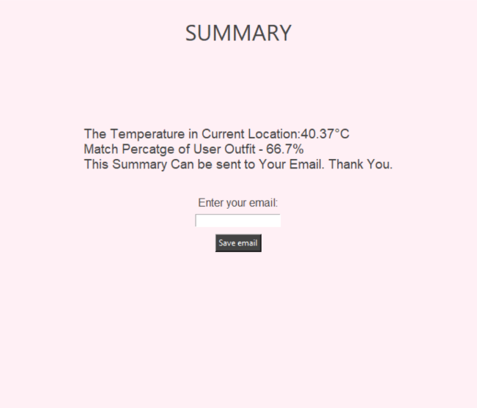

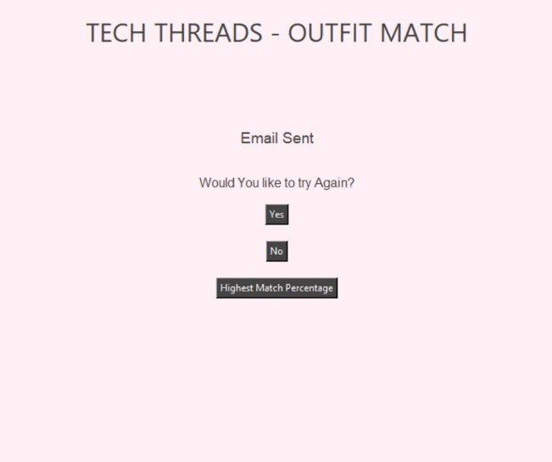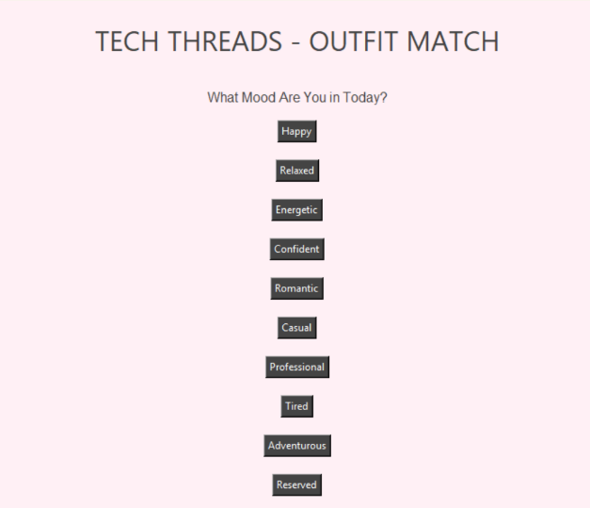



How it works

* User selects their mood, event, outfit components (top/bottom/dress/etc.).
* System fetches temperature using weather API.
* Uses this and user input to generate fashion trend keywords.
* Queries Google Trends for popularity of related keywords.
* Compares user outfit components with trend data and calculates a match %.
* Displays the result and allows the user to email a summary.
*  Option to check highest match combo so far.

Get Started

*Requirements:*

* Python 3.x
* Libraries: tkinter,requests,smtplib,sqlite3,pytrends

*Installation*

git clone https://github.com/yourusername/techthreads.git

cd techthreads

python techthreadsfinal.py



Gmail App Password Setup(For Email Feature)

* Enable 2FA on your Gmail
* Go to Google Account > Security > App passwords
* Generate a new app password(e.g. name it techthreads)
* Use this password in your code instead of your actual password



Example Use Case

* Mood: “Happy”
* Event: “Party”
* Outfit keywords: Cotton White T-Shirt with Skinny Blue Denim Full length Pants
* Trend Keywords: Happy Party outfit, Party fashion, Party wear, Happy style, summer fashion
* 6 out 9 outfit keywords matched
* Result: Match % = 66.7%



Sample Email Output

Temperature at Your Location: 32°C

Outfit match percentage: 66.7%

Thank You for Using TechThreads.



Project Type

* This is a full-stack Python GUI application, built entirely without web frameworks
* Suitable for showcasing API integration, logic building, data persistence, and user interface design



Status

✅ Completed — Personal Project for Portfolio  
👤 Built after Year 1 of College (July 2025)

Future Improvements

* Add ML- powered outfit recommendations
* Better styling and animations for GUI



About the Developer

* *Name:* Varsha Murugesan
* *Year:* Entering Second Year
* *University:* Heriot Watt University
* *GitHub:* @varsha-m2006

**